**Name:** Atharva Salitri

**Year & Branch:** TY-CSAI-B

**Batch:** 2

**Roll no:** 29

**PRN:** 12310120

**Subject:** Cloud Computing

**Cloud Computing Assignment 5**

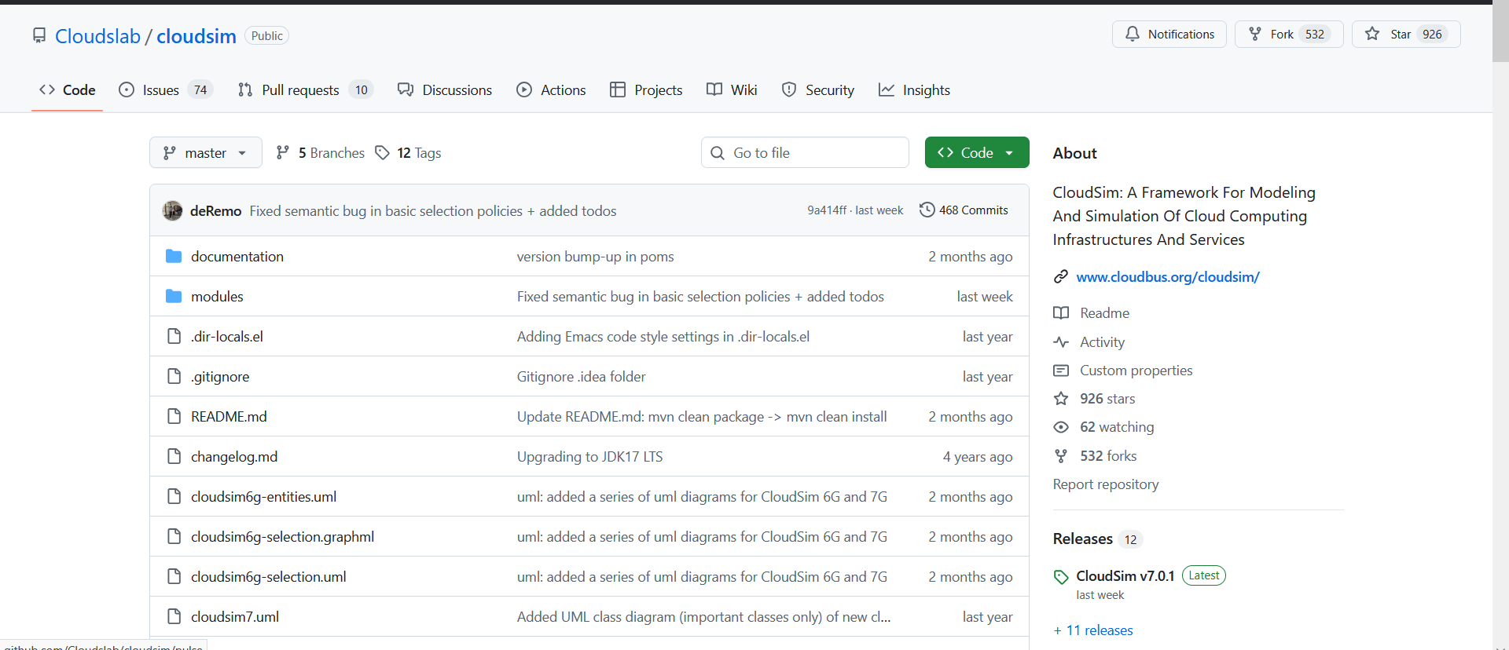

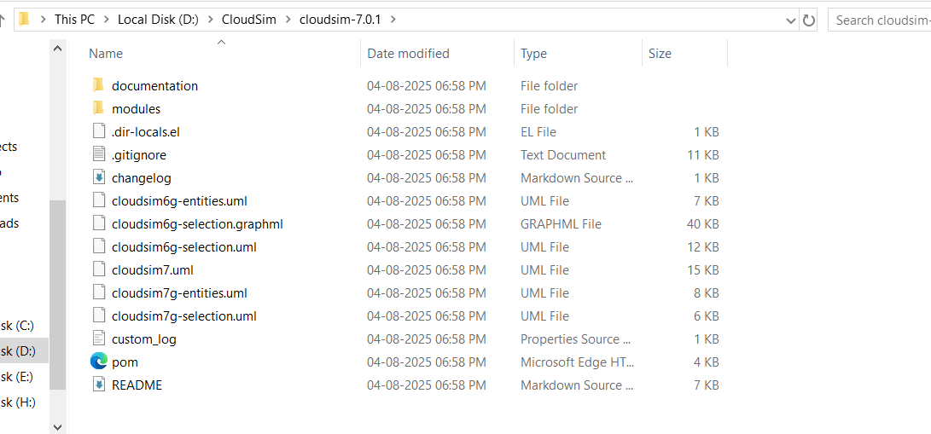

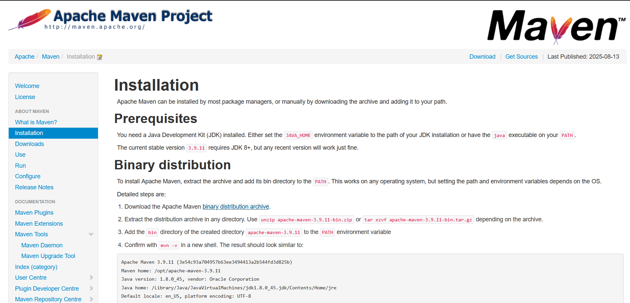

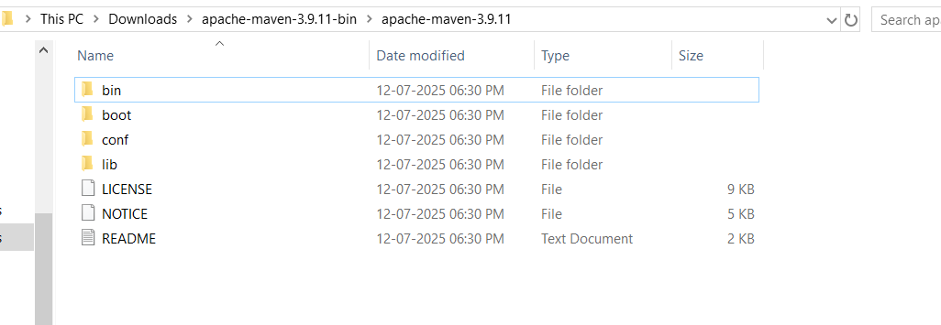

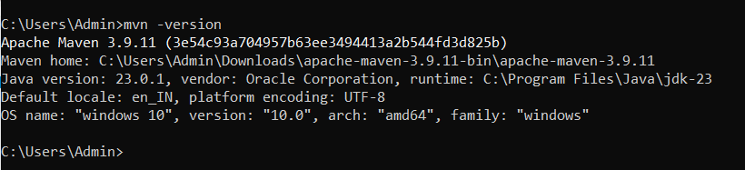

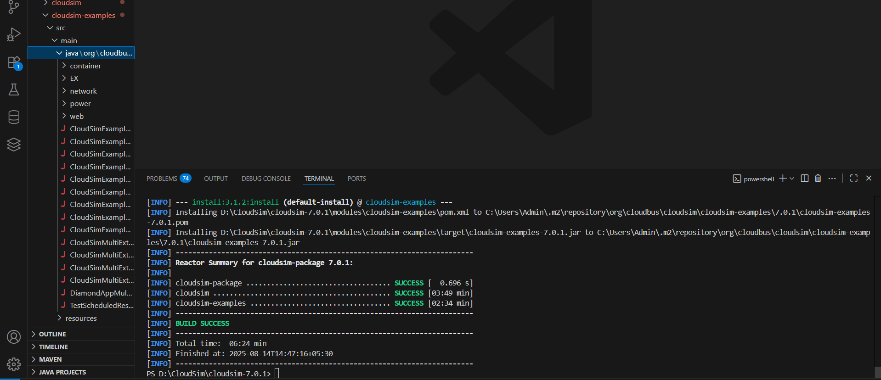

After running example 9 and updating the example

